|  |
| --- |
| Neighborhood Battle-London  2019 |
|  |
| August 11  Authored by: Sharmila |

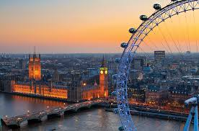

# Table Of Contents

# Title……………………………………………………………………PageNo.

# Introduction/Business Requirement…………..………………...………….3

# Data……………………………………………………………………………3

# Introduction/Business Requirement

# The intention of this project is to compare London and Paris. The analysis would be done based on various list of venues generated by the foursquare API in these neighborhood

# to determine which neighborhood is better for tourist. The analysis would be done based on the various aspects which could make it comfortable for a tourist and the data available from the various files available in the datasets whose details are provided in the data section.

# Data Section

# The following data sets, which includes data from Wikipedia and the other open source data in .csv formats would be highly appropriate, extensive and helpful in analyzing and visualizing data in determining which is the better neighborhood for tourist.

# <https://en.wikipedia.org/wiki/List_of_postcode_areas_in_the_United_Kingdom>

# ukpostcodes.csv

# Postcode_districts.csv

# <http://freakonometrics.free.fr/popfr19752010.csv>

# Hate_Crimes_by_County_and_Bias_Type__Beginning_2010.csv

# tourism-trips-borough.csv

# ukpostcodes.csv

# Essex_County_Tourist_Attractions.csv

# recrime-geo-pfa.csv

# NYPD_Shooting_Incident_Data__Year_To_Date_.csv

# international-visitors-london-raw.csv

# NYPD_Complaint_Data_Current.csv

# 